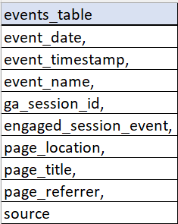**Events Data Pipeline**  
  
Your task is to write a python script that extracts the events file from the source folder and load the required fields in any database system of your choice.  
  
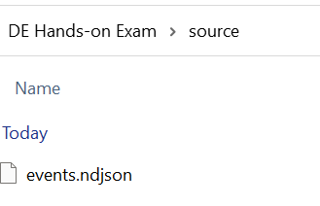  
  
Below is the table format and the required fields

After loading the data in the events_table, your python script should also be able to extract the data from the events_table and save it as **events.csv** in the target folder.  
  
